**Problem4 : Module 3**

1. Star Schema is used as only five dimensions are there.
2. A New Fact Table Name SalesRecord is made.

It maintains the entry for each productService/Merchandise bought.

It has following fields:

* SalesRecordNo (Primary Key)
* SalesQty( As it was there in Contains Table)
* SalesUnitPrice(Price of Merchandise,Price of Service,may be ServiceCategory,Special Events,Membership Price from MemberType Table)
* SalesTotalAmt (Keep Track of Total Money Earned)
* isService (Yes or No)

To check entry recorded is of Service or not.

* isMerchandise (Yes or No)

To check Entry recorded is of merchandise or not.

1. Other 5 Dimension Tables are as follows:

**Franchise**

FranchId (primary key)

FranchRegion

FranchPostalCode

FranchModelType

**Member**

MemId (Primary Key)

MemName

MemZip

MemDate(MembershipDate)

MemEmail

MemType (Taken from ERD MemType Table)

(Default values for Guest, Corporate Cust)

**Calendar**

CallId (primary key)

CallDay

CallMonth

CallYear

**ProductService**

ProdId(Primary Key)

ProdName

ProdType (Special Event,Service,MemberShip)

**Merchandise**

MerchId (Primary Key)

MerchName

MerchType

SalesRecord **Of** ProductService/Merchandise **Bought By** Member **On** Calendar Suppiled **By** Franchise

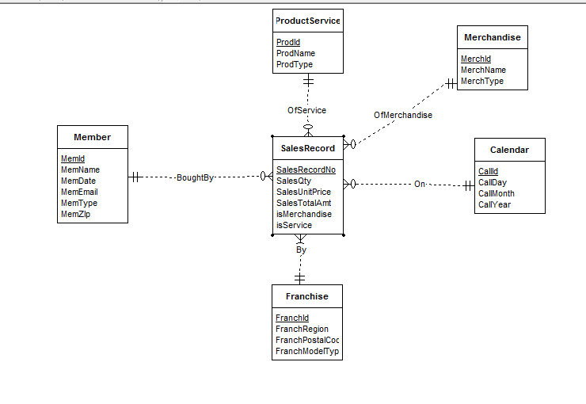

The diagram shows the star schema , with salesrecord as the middle and other dimensions have 1 to Many relationships to it.

Each Entry into the database contains the record of the productservice whether it is Service or Special Event into the database or Membership(Gold,Platinum,Value) or of merchandise.